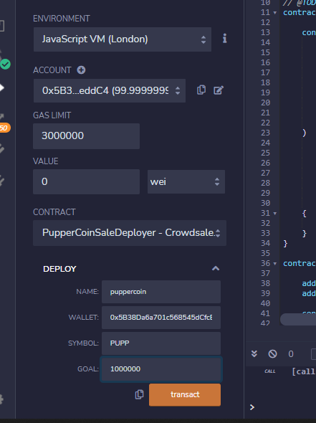

I set my contract to PupperCoinsaledeployer.

I put the name of my Coin, Wallet is the beneficiary of the sale, Symbol, and goal.

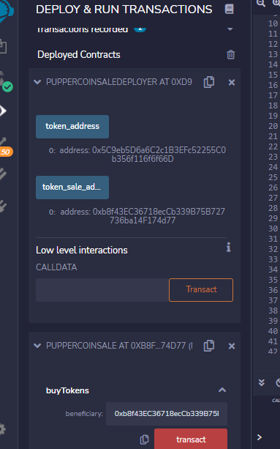

Now that the contract is deployed, I copied the token sale address to launch the contact.

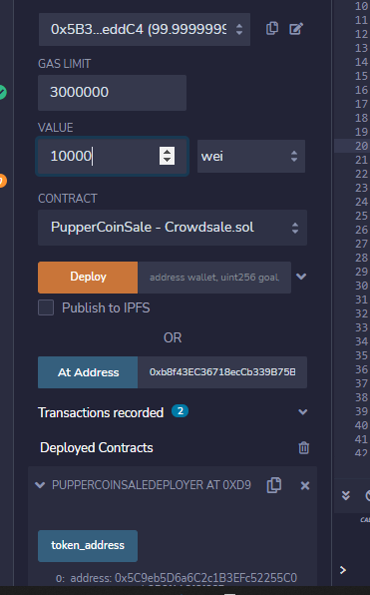

I paste the address to AT address

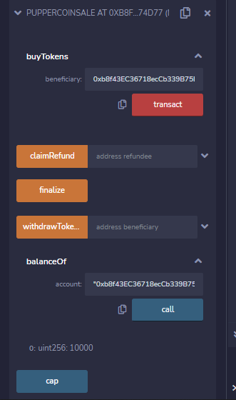

Here is where I bought the token and check the balance.

